Project Synopsis
On

AI Powered Desktop Assistant

Submitted as a part of course curriculum for

Bachelor of Technology
in
Computer Science and Engineering

Submitted by
Aditi Agrawal (2200290100010)
Abha Gangwar (2200290100004)
Ekta (2200290100067)

Under the Supervision of
Dr. Ankur Bhardwaj

KIET Group of Institutions, Ghaziabad
Department of Computer Science and Engineering
Dr. A.P.J. Abdul Kalam Technical University
Year: 2024-25

ACKNOWLEDGEMENT

It gives us a great sense of pleasure to present the synopsis of the B.Tech Major Project undertaken during B.Tech. Third Year. We owe a special debt of gratitude to Dr. Ankur Bhardwaj, Department of Computer Science and Engineering, KIET Group of Institutions, Delhi- NCR, Ghaziabad, for hisconstant support and guidance throughout the course of our work. His sincerity, thoroughness and perseverance have been a constant source of inspiration for us. It is only his cognizant efforts that our endeavours have seen the light of the day.
We also take the opportunity to acknowledge the contribution of Dr.Vineet Kumar Sharma, Head of the Department of Computer Science and Engineering, KIET Group of Institutions, Delhi- NCR, Ghaziabad, for his full support and assistance during the development of the project. We also do not like to miss the opportunity to acknowledge the contribution of all the faculty members of the department for their kind assistance and cooperation during the development of our project.
Last but not the least, we acknowledge our friends for their contribution to the completion of the project.

Signature:
Student’s Name:
Aditi Agrawal
Abha Gangwar
Ekta

Guide Name & Signature:
Dr. Ankur Bhardwaj

Signature: Project coordinator :
Mr. Vipin Deval

ABSTRACT

In an era where intelligent systems are reshaping human-computer interaction, this project presents JARVIS – an AI-powered desktop assistant designed to enhance user productivity through intelligent automation and real-time responsiveness. JARVIS serves as a virtual assistant capable of understanding both voice and text inputs, performing desktop automation tasks, and responding to user queries with context-aware, human-like replies.
The assistant integrates multiple technologies including speech recognition, text-to-speech synthesis, natural language processing using Hugging Face transformers, and task automation with tools like Selenium. The GUI, developed with PyQt5, provides an engaging user interface enhanced with animated elements. JARVIS can perform a range of actions such as opening applications, browsing the web, fetching real-time information through APIs, and managing user-specific tasks efficiently.
This project aims to bridge the gap between traditional automation tools and modern AI interfaces, offering a seamless, intuitive, and intelligent interaction experience. The modular architecture ensures scalability and adaptability, making JARVIS a foundational step toward building more advanced AI-powered personal assistants.

TABLE OF CONTENTS

TITLE PAGE ................................................................................................................. i
ACKNOWLEDGEMENT ............................................................................................ ii
ABSTRACT .....................................................................................................................iii
LIST OF FIGURES .........................................................................................................vi
LIST OF ABBREVIATIONS ........................................................................................v
CHAPTER 1 INTRODUCTION ................................................................................. 5-8
1.1. Introduction .................................................................................................... 5
1.2. Problem Statement ....................................................................................... 6
1.3. Objective ......................................................................................................... 7
1.4. Scope ................................................................................................................ 8
CHAPTER 2 LITERATURE REVIEW ..................................................................9-12
2.1. Personal AI Desktop Assistant – Rabin Joshi et al. .................................. 10
2.2. Voice Recognition System – Atishay Jain et al. ...................................... 11
2.3. Speech-to-Text and TTS – Dr. M. Anusha et al. ....................................... 12
CHAPTER 3 PROPOSED METHODOLOGY .................................................... 13–15
3.1. Flowchart ....................................................................................................... 13
3.2. Algorithm Proposed ...................................................................................... 14
3.3. Key Methodological Steps .......................................................................... 15
CHAPTER 4 TECHNOLOGY USED .................................................................... 16-17
CHAPTER 5 CONCLUSION ...................................................................................... 18
REFERENCES ................................................................................................................19

CHAPTER 1

1.1
INTRODUCTION

With the rapid advancement of artificial intelligence and human-computer interaction, the demand for intelligent virtual assistants has grown significantly. From simplifying everyday tasks to enhancing productivity, AI-powered assistants are transforming the way users interact with their digital environments. This project introduces JARVIS (Just A Rather Very Intelligent System) – an AI-powered desktop assistant inspired by the fictional assistant from the Marvel universe, reimagined using real-world technologies.
JARVIS is a voice and text-responsive assistant designed to perform a wide array of tasks such as opening applications, browsing the internet, retrieving real-time information, setting reminders, and more. By integrating technologies like speech recognition, natural language processing, task automation, and graphical user interfaces, JARVIS offers users a seamless, interactive, and intelligent computing experience.
The system is built using Python, incorporating libraries like SpeechRecognition, pyttsx3, Hugging Face Transformers, and Selenium for functionality, along with PyQt5 for a visually engaging and user-friendly interface. It acts as a bridge between user intent and machine execution, understanding commands and executing them efficiently.
JARVIS is not just a tool but a step toward building real-world intelligent systems capable of learning, adapting, and supporting users in daily digital tasks. Its design is modular and scalable, allowing future enhancements such as IoT integration, multi-language support, and cloud synchronization. This project aims to explore the practical implementation of AI in personal desktop environments, showcasing the potential of smart assistants in improving user efficiency and experience.
1.2
PROBLEM STATEMENT

In today’s fast-paced digital world, users often perform repetitive tasks manually—such as opening applications, browsing the web, managing files, or searching for information—which can be time-consuming and inefficient. Traditional user interfaces lack the intelligence to understand natural language commands or adapt to user preferences over time.
There is a growing need for a smart, interactive system that can streamline daily computer operations, reduce manual effort, and provide a more intuitive way for users to interact with their machines. The challenge lies in building an AI-powered desktop assistant that not only understands voice and text commands but also responds intelligently and performs actions in real time.
This project aims to address this need by developing JARVIS, a desktop assistant capable of understanding natural language, automating tasks, and enhancing user productivity through intelligent interaction.

1.3
OBJECTIVE

The objective of this project is to develop an AI-powered desktop assistant that enhances user productivity, simplifies routine tasks, and enables intuitive human-computer interaction through voice and text commands. The system will:
- Utilize speech recognition and natural language processing (NLP) to understand user commands in real time and provide appropriate, context-aware responses.
- Automate desktop operations such as opening applications, performing web searches, managing files, and retrieving real-time information using Python-based automation tools.
- Integrate with Hugging Face transformers and other APIs to enable intelligent conversational abilities and knowledge-based interactions.
- Provide a user-friendly and visually engaging interface using PyQt5, enriched with animations and real-time feedback for an immersive user experience.
- Ensure modularity and scalability, allowing for future enhancements such as IoT integration, multi-language support, and personalization based on user behavior.
This solution aims to deliver a robust, efficient, and intelligent desktop assistant that demonstrates the practical application of artificial intelligence in everyday computing tasks.

1.4
SCOPE

The scope of this project is to design and implement an AI-powered desktop assistant capable of understanding natural language commands and performing intelligent automation to improve human-computer interaction. Key aspects of the project include:
- Natural Language Understanding:
Integration of speech recognition and NLP models to enable the assistant to understand voice and text commands, offering real-time responses and interactive communication.
- Task Automation:
The assistant will perform desktop-level automation such as opening applications, executing searches, fetching system information, and managing files, reducing the need for manual operations.
- Intelligent Conversational Interface:
The use of Hugging Face transformer models and APIs to deliver context-aware, human-like responses that enhance the overall user experience and engagement.
- Graphical User Interface (GUI):
A modern, animated interface built with PyQt5 will allow users to interact with the assistant easily through both text and voice, ensuring accessibility and visual appeal.
- Scalability and Personalization:
The assistant will support customization based on user preferences, with the potential to scale into more advanced domains like smart home integration, productivity tracking, and multi-language support.
This project is aimed at personal computer users seeking an AI-driven solution for enhanced desktop automation and interactive assistance, with the flexibility to grow into a fully personalized virtual companion.

CHAPTER 2

LITERATURE REVIEW

2.1

Personal AI Desktop Assistant – Rabin Joshi et al. (IJITRA, 2023)
This paper introduces a highly customizable and extensible AI desktop assistant designed using Python. The assistant is capable of performing a range of computer-related tasks through voice commands, offering users a hands-free and intelligent computing experience. The motivation behind this project lies in making computer interactions more efficient and natural by leveraging AI and voice processing technologies. The assistant integrates functionalities such as launching applications, reading Wikipedia summaries, checking emails, playing music, and performing web-based tasks—thereby acting as a multipurpose virtual assistant for personal use.
Key Highlights:
- Library Integration: The system utilizes several Python libraries like SpeechRecognition for converting voice to text, pyttsx3 for converting text responses into speech, and webbrowser for opening URLs and accessing online content programmatically. These libraries together form the core of the assistant’s voice interface, enabling smooth and accurate voice command processing.
- API Integration: The assistant supports a variety of external APIs to enhance its functionality. APIs are used to fetch real-time information such as news updates, weather data, or perform tasks like simple mathematical calculations. This dynamic integration ensures that the assistant remains informative and responsive to diverse queries.
- User Personalization: One of the standout features of this system is its support for personalization. Users can customize the assistant's voice (e.g., choosing between male and female voices), set preferred command structures, and even modify behavior to suit specific needs. This ensures a more tailored and user-friendly experience.
- Flexible Backend: The assistant is designed to be lightweight and adaptable, offering continuous listening capabilities and adjustable voice detection durations. This flexibility allows users to configure how the assistant listens—whether continuously or only when triggered by a wake word or button.
- Modular Design: The backend of the assistant follows a modular structure where new functionalities can be added easily without altering the core system. This makes it highly scalable and suitable for integration with future technologies like IoT, smart home automation, or cloud services.
Relevance to Project: This research aligns perfectly with the core objectives of the JARVIS AI-powered desktop assistant project. It demonstrates how Python, when combined with well-chosen libraries and API integrations, can deliver a robust personal assistant capable of both static and dynamic task execution.

2.2
Voice Recognition System for Desktop Assistant – Atishay Jain et al. (ICCBV, 2022)
The research by Atishay Jain et al. (ICCBV, 2022) is relevant to your AI-powered desktop assistant project for several reasons:
- Hybrid Command-Processing Model: The paper combines speech recognition and NLP for command processing, which aligns with your project’s goal of using both voice and text for interaction. This ensures users can interact with your assistant in multiple ways—either by speaking or typing.
- Offline Speech-to-Text (STT): They use offline STT to maintain functionality in low-connectivity environments. Similarly, integrating an offline STT system in your assistant will ensure it remains functional even without a stable internet connection.
- GUI Integration (Tkinter vs PyQt5): While they use Tkinter for the GUI, your use of PyQt5 will allow for more advanced, visually rich interfaces, like animations. This will support your voice-command system and make the assistant more interactive.
- Natural-Sounding Text-to-Speech (gTTS): The paper uses gTTS for natural TTS, which you can also implement to provide lifelike responses in your assistant, enhancing user engagement.
Relevance: The integration of GUI with speech-based command control supports the hybrid interaction model adopted in your assistant using PyQt5 and animated interfaces.

2.3

Speech-to-Text and Text-to-Speech Recognition – Dr. M. Anusha et al. (IJFANS, 2022)
This review paper extensively covers the evolution of speech technologies, outlining both STT and TTS systems powered by deep learning.
Key Highlights:
- ASR Pipeline: Acoustic Modeling, Language Modeling, and Decoding: The paper discusses using CNNs for acoustic modeling, RNNs/Transformers for language modeling, and deep learning for decoding. This aligns with your project’s goal of using advanced models like Transformers to improve speech recognition accuracy and decoding efficiency.
- TTS Methods: Concatenative, Statistical, and Deep Learning Approaches: The research highlights concatenative synthesis and statistical parametric synthesis, while modern methods like deep learning (e.g., WaveNet) offer more natural speech synthesis. This is relevant to your project, where you can implement deep learning-based TTS to generate more expressive and natural-sounding responses.
- Real-World Applications: The research emphasizes real-world applications in accessibility, virtual assistants, and transcription services, all of which are directly applicable to your project’s use cases, such as making your assistant accessible to a wide range of users and integrating transcription features.
- Challenges: Accuracy in Noisy Environments and Speaker Variability: The paper mentions challenges in accuracy due to noise and speaker variability, which you will also encounter. You can address this by using noise-robust algorithms and speaker adaptation techniques in your assistant.
Relevance:
Provides strong theoretical grounding for the speech interaction layer in your assistant, validating the choice of ASR and TTS models for reliable voice-based command execution.

CHAPTER-3

PROPOSED METHADOLOGY

3.1
FLOWCHART

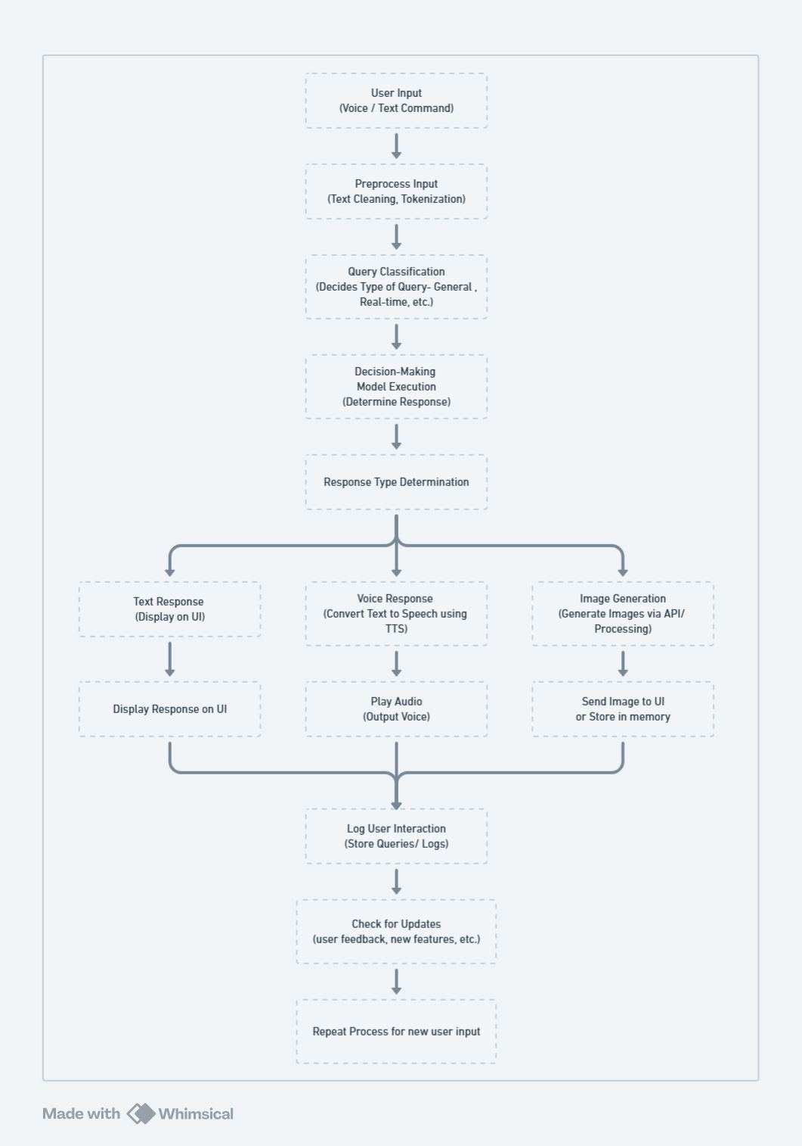
3.2
ALGORITHM PROPOSED

- User Input: The flow starts with user input which can be in the form of voice commands or text queries.
- Preprocess Input: The input is preprocessed for analysis, which includes steps like cleaning and tokenization.
- Query Classification: The type of query is identified, such as whether it's a general inquiry, a request for real-time information, automation, etc.
- Decision-Making Model Execution: The AI uses a decision-making model to determine appropriate responses based on classified queries.
- Response Type Determination: The system decides how to respond—text reply, voice output, or image generation.
- Text Response: If the output is text, it is displayed on the user interface.
- Voice Response: If the output is voice, the text response is converted to speech using text-to-speech (TTS) technology.
- Image Generation: If the output requires an image, the system generates it using APIs or processing algorithms.
- Display Response: Displays text answers on the UI, plays audio responses, or sends generated images to the UI.
- Log User Interaction: The user's queries and interactions are logged for future reference or analysis.
- Check for Updates: Regularly check for updates regarding user feedback, potential enhancements, or new features.
- Repeat Process: Once the current user interaction is complete, the system is ready to receive new input and continues working.

This structured flowchart is designed to give a clear view of how the Jarvis-like AI operates from user input to response generation. For visual representation, you can use diagramming tools as previously mentioned.

3.3
KEY METHADOLOGICAL STEPS

- The assistant listens continuously or on-demand for user input via microphone or GUI.
- Input text is preprocessed using basic NLP methods for tokenization and cleaning.
- Classification module identifies whether the query is informational, task-based, or system command.
- Based on the query, an appropriate response is selected using rule-based or language model inference (e.g., using Cohere/Groq).
- If the action involves search or automation, respective libraries (like Selenium or pywhatkit) are invoked.
- The output is processed for TTS (if voice), displayed on GUI (text/image), or both.
- Each user interaction is logged for improvement, and the loop resets for further input.

CHAPTER 4

TECHNOLOGY USED

4.1 User Input (Voice/Text)
- Speech Recognition:
  - edge-tts – For voice input and natural-sounding TTS responses.
  - pygame – To play audio responses.
- Text Input:
  - PyQt5 – GUI for input fields and chat interface.
  - keyboard – To capture global hotkeys or input events.

4.2 Preprocessing & NLP
- Text Cleaning & Tokenization:
  - cohere – For language understanding and embeddings.
  - mtranslate – For multilingual support if needed.

4.3 Query Classification & Decision Making
- Model Integration & Logic:
  - groq – For fast execution of large language models (LLMs).
  - cohere – Semantic understanding and response generation.
  - Custom rule-based or ML logic.

4.4 Web & Task Automation
- Search & Info Retrieval:
  - googlesearch-python – Google search queries.
  - bs4, requests – Scraping and retrieving web content.
- Task Automation:
  - pywhatkit – To send WhatsApp messages, play YouTube videos, etc.
  - AppOpener – Launch local apps through voice commands.
  - selenium, webdriver-manager – Web automation and interaction.

4.5 Response Generation
- Text-to-Speech (TTS):
  - edge-tts – Converts responses into natural-sounding voice.
- Display & Visuals:
  - PyQt5 – GUI display with animated GIFs and interactive layout.
  - pillow – Image processing and display.
  - rich – Styled terminal output or logs (if CLI used).

4.6 Image & Media Handling
- Image Generation/Rendering:
  - pillow – For creating/modifying images dynamically in responses.

4.7 Environment Management
- Secrets & Configs:
  - python-dotenv – For managing API keys and environment variables securely.

4.8 Logging & Feedback
- Data Logging/Storage:
  - PyQt5 integrated file logging or database (optional: SQLite, TinyDB)
  - rich – For beautifully formatted logs and debug messages in terminal.

CHAPTER 5

CONCLUSION

This project presents an intelligent and efficient solution for enhancing desktop productivity and personal assistance through an AI-powered system integrated with both voice and text command capabilities. The hybrid command-processing architecture—utilizing state-of-the-art language models (like those powered by Groq and Cohere), voice recognition (via edge-tts), and task automation (using tools such as pywhatkit, AppOpener, and Selenium)—ensures a seamless and intuitive interaction model that adapts to user needs.
The system’s offline functionality, animated PyQt5 GUI, and integration with APIs for search, communication, and image generation make it highly interactive, responsive, and user-centric. With real-time decision-making models, speech output, and multitask handling across diverse user queries, this assistant bridges the gap between natural communication and digital execution.
In addition, features like quick app launching, WhatsApp messaging, and web scraping for answers enable the assistant to serve as a comprehensive digital companion. It also logs user queries and adapts to feedback, making it robust for long-term usage and personalization.
This solution modernizes the concept of personal virtual assistants by combining machine learning, automation, and natural language understanding into a compact, desktop-based tool. It is lightweight, scalable, and privacy-friendly due to its local execution model, offering a smart and accessible AI experience tailored to the evolving needs of users.

REFERENCES

- Atishay Jain et al. (2022). Voice Recognition System for Desktop Assistant. Proceedings of the International Conference on Computing, Communication and Bioinformatics (ICCBV).
– Explores hybrid command processing with speech and GUI integration.
- S. Sharma, R. Kumar, A. Mittal. (2021). A Review on Speech Recognition and Text-to-Speech Synthesis Using Deep Learning.
– Discusses ASR pipeline, TTS approaches, and challenges in noisy environments.
- Rabin Joshi et al. (2023). Personal AI Desktop Assistant. International Journal of Information Technology Research and Applications (IJITRA).
– Presents a customizable desktop assistant using Python, with features like dynamic API integration, continuous listening, and voice personalization.
- Jhurani, J. (2022). Automation in Workday Using Python-Selenium. International Journal of Computer Engineering and Technology (IJCET), 13(1), 65–75.
– Demonstrates Python-Selenium automation for HR workflows in Workday, improving efficiency and accuracy in benefit group management.
- Abdul Wali, Saipunidzam Mahamad, Suziah Sulaiman. (2023). Task Automation Intelligent Agents: A Review. Future Internet, 15(6), 196.
– Reviews task automation systems and intelligent agents with a focus on programming-by-demonstration and the need for domain-specific usability heuristics.

.

